This section will guide you to:

● Configure a Servlet with Eclipse

* Open Eclipse
* Go to the **File** menu. Choose **New->Dynamic Web Project**
* Enter the project name as **FirstServlet**. Click on **Next**

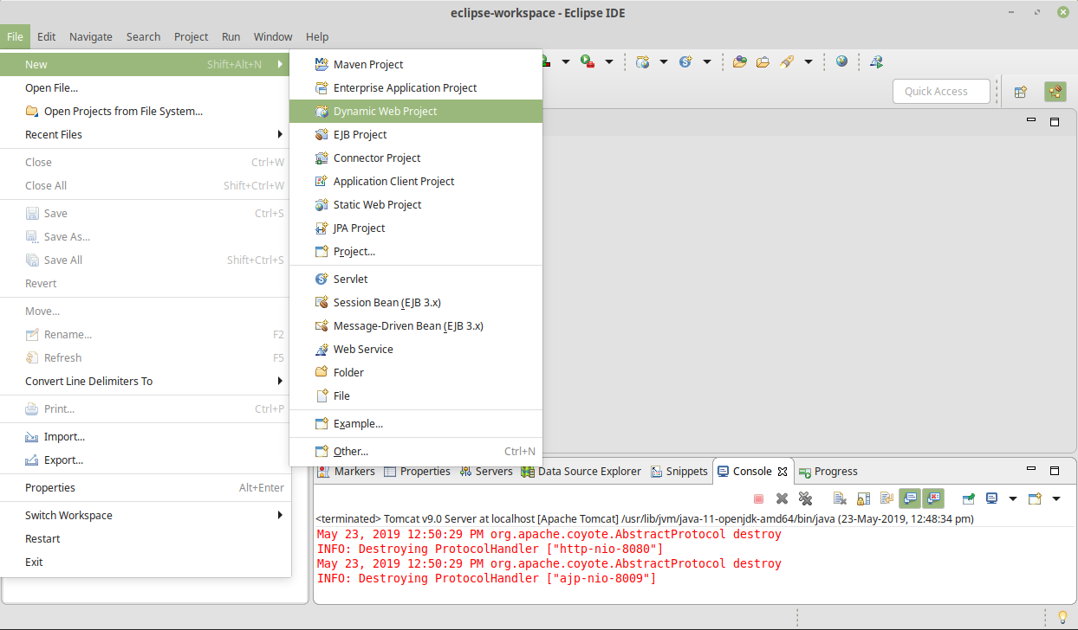

* Enter the project name as **FirstServlet**. Click on **Next**

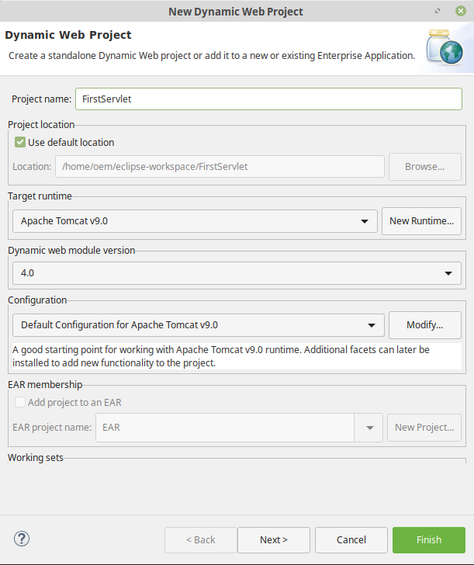

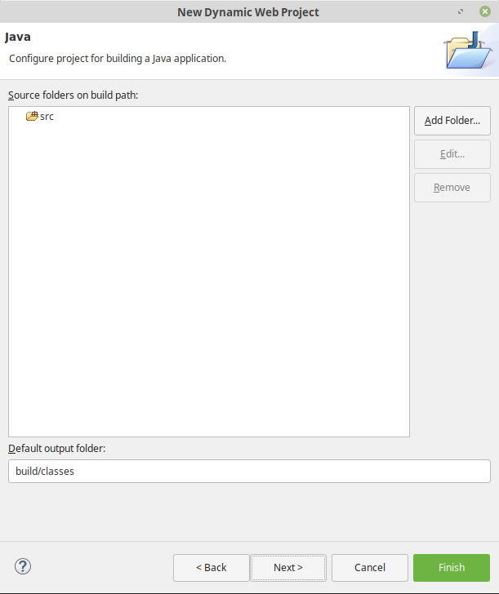

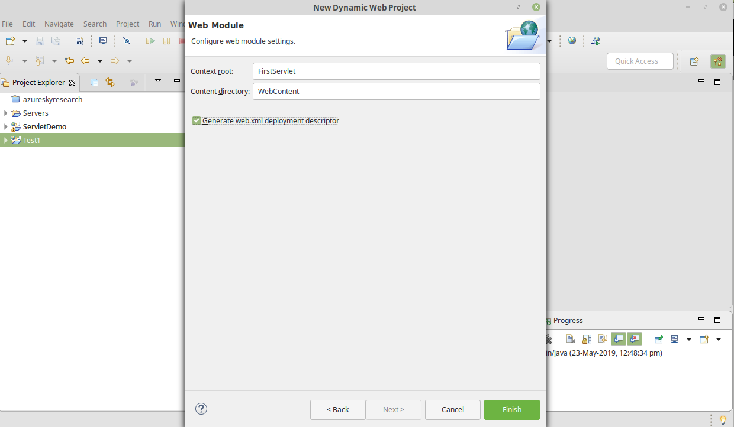

Creating a servlet

* In the Project Explorer, expand **ServletConcept->Java Resources**
* Right click on **src** and choose **New->Servlet**
* In **Class Name,** enter **FirstServlet** and click on **Finish**

